The Constantinus European Award continues to succeed. (Vielleicht eher: Constantinus Award goes to two Spanish, one Austrian and one Romanian management consultant)
On the 6th of October in Brussels three companies were awarded with the Constantinus European Award
FEACO promotes exceptional management consulting projects
The leading management consultants are important sparring partner for businesses and entrepreneurs - especially when expertise and efficient implementation of measures are in demand. "Naturally the quality of the consulting sector relies on the innovative strength of the consultants themselves. This is why FEACO has initiated the Constantinus European Award in order to provide for the fourth time a prominent stage for all excellent contributions of the branch", states Ezio Lattanzio, chairperson of FEACO.

The primary objective of this award is the promotion of individual and outstanding consulting projects not only nationally but also in Europe. The Constantinus European Award also serves as a platform for international cooperation and networking. For the nominees this award will be an important tool for strengthening their client-consultant-relationship by celebrating successful joint efforts and in addition by raising the international recognition for their projects. "The European Constantinus Award honours the beacons of management consultancy & IT on a European level and increases cross-border competition", outlines Alfred Harl, Chair Constantinus European, the uniqueness of this award.
The Constantinus European Award 2016 was awarded in Brussels.
Many national institutes followed the invitation of FEACO and participated in the award process. The institutes nominated national projects considered as outstanding. Finally an international and renowned jury had the chance to evaluate these projects. The award ceremony 2016 took place on October 6th in Brussels. This year the national champions were the Spanish management consuting company EY Spain, the Austrian company SLIM Interim Management and the Romanian company DAL CONSULTING.

Gold Medal for Spain, silver for Austria and Spain.
This year’s Gold Medal was awarded to the Spanish champion EY Spain for the Project “DRIVER in Bergé Automotive” which included a business transformation, a redesign and a full SAP and salesforce implementation. EY has been selected by Bergé Automoción as the preferred consulting company to carry out the implementation of DRIVER initiative. The model lies upon the premise of a comprehensive integration across CRM and transactional applications that enables a synchronized model from the OEM procurement down to the final sales to 2nd tier customer. The project follows a customer centric approach where individuals can interact with Bergé enabling a direct customer relationship.

The first of two Silver Medals went to the Austrian champion SLIM Interim Management Consulting GmbH for the project “Management in stormy waters”, a turnaround and internationalization process of SIHGA Handels GmbH, a leading medium-sized family-owned company. SIHGA is a system supplier of fastening technology in wood construction. A decline of profits, a separation process between SIHGA and a close business partner as well as a helicopter crash of the owner brought along a challenging situation for SIHGA. The interim manager Siegfried Lettman led the company through "heavy waters". Lettman acted as a provisional CEO and stabilized the situation, talked to the employees and continued the daily operations and took over the operational duties of the "lost" CEOs. He also identified the causes of SIHGA's unfavorable economic development and developed and implemented necessary measures to lead SIHGA back to healthy economic growth. In 2014 SIHGA finally generated its highest turnover and largest profit in history.

The second Silver medal went to IBM Global Business Solution in Spain for their Project “A Real Transfomation Experience”, an OmniChannel initiative at El Corte Inglés S.A. Various conditions had forced El Corte Inglés to define a strategic roadmap that would transform it into an omnichannel retail company. Synergies were derived from having a strong digital presence and hundreds of distribution centres. The project completely modernised and reorganised the logistics of the company, especially how orders captured by the digital channels are sourced and delivered. The processes were streamlined, new delivery methods were designed and new supporting systems were implemented setting up El Corte Inglés as leader of the retail industry again.

GOLD:
Participant: EY Spain
Client: Bergé Automoción
Project: DRIVER in Bergé Automotive: Business transformation and redesign / full SAP and Salesforce implementation
Country: Spain

SILBER:
Participant: SLIM Interim Management
Client: SIHGA Handels GmbH
Project: Management in stormy waters - Turnaround and internationalization of a leading medium-sized family-owned company
Country: Austria

SILBER:
Participant: IBM Global Business Solution
Client: El Corte Inglés S.A
Project: A Real Transfomation Experience: OmniChannel Initiative at El Corte Inglés
Country: Spain

The other Nominees
- nimbusec GmbH / Austria.
- Research Industrial Systems Engineering (RISE) GmbH / Austria.
- Awarity Training Solution GmbH / Austria.
- ACCENTURE / Spain.
- Sofa Creative Media GmbH / Austria.

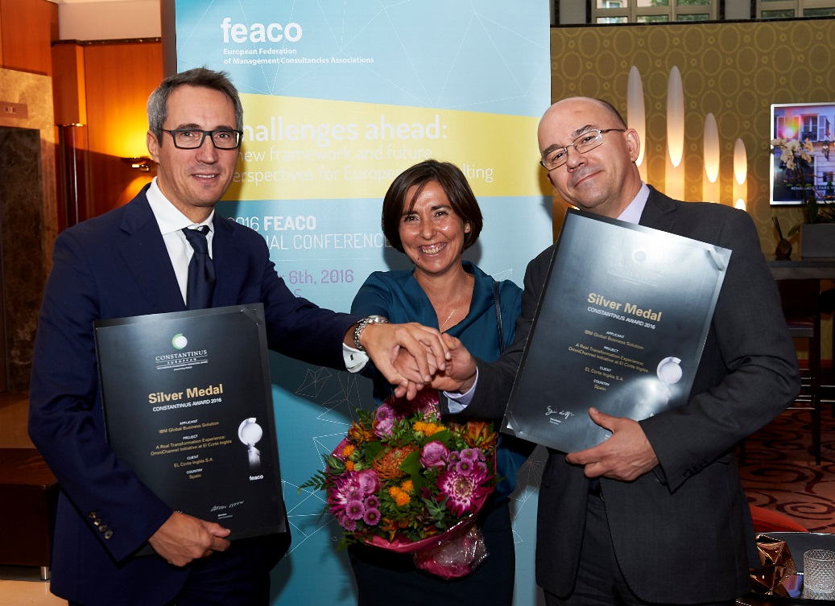
Picture (FV UBIT / FEACO) with Silver Medal Winner IBM Global Business Solution & El Corte Inglés S.A.

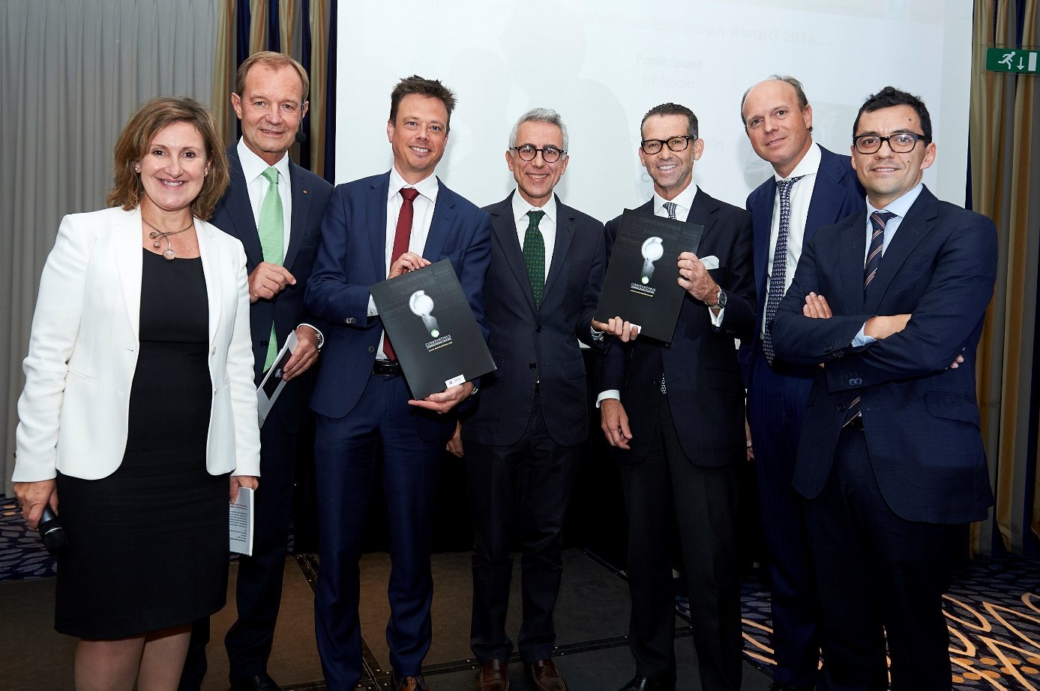
Picture (FV UBIT / FEACO) with Gold Medal WInner and spanish Champion EY Spain and Bergé Automoción (left to right): Mercedes Sanchez (moderation), Alfred Harl (Chair Constantinus Europe), Manuel Giralt (Risk Managing Partner at EY), Ezio Lattanzio (President FEACO), Sebastián Canadell (Managing Director at Bergé) and Jorge Estevez (Director at EY).

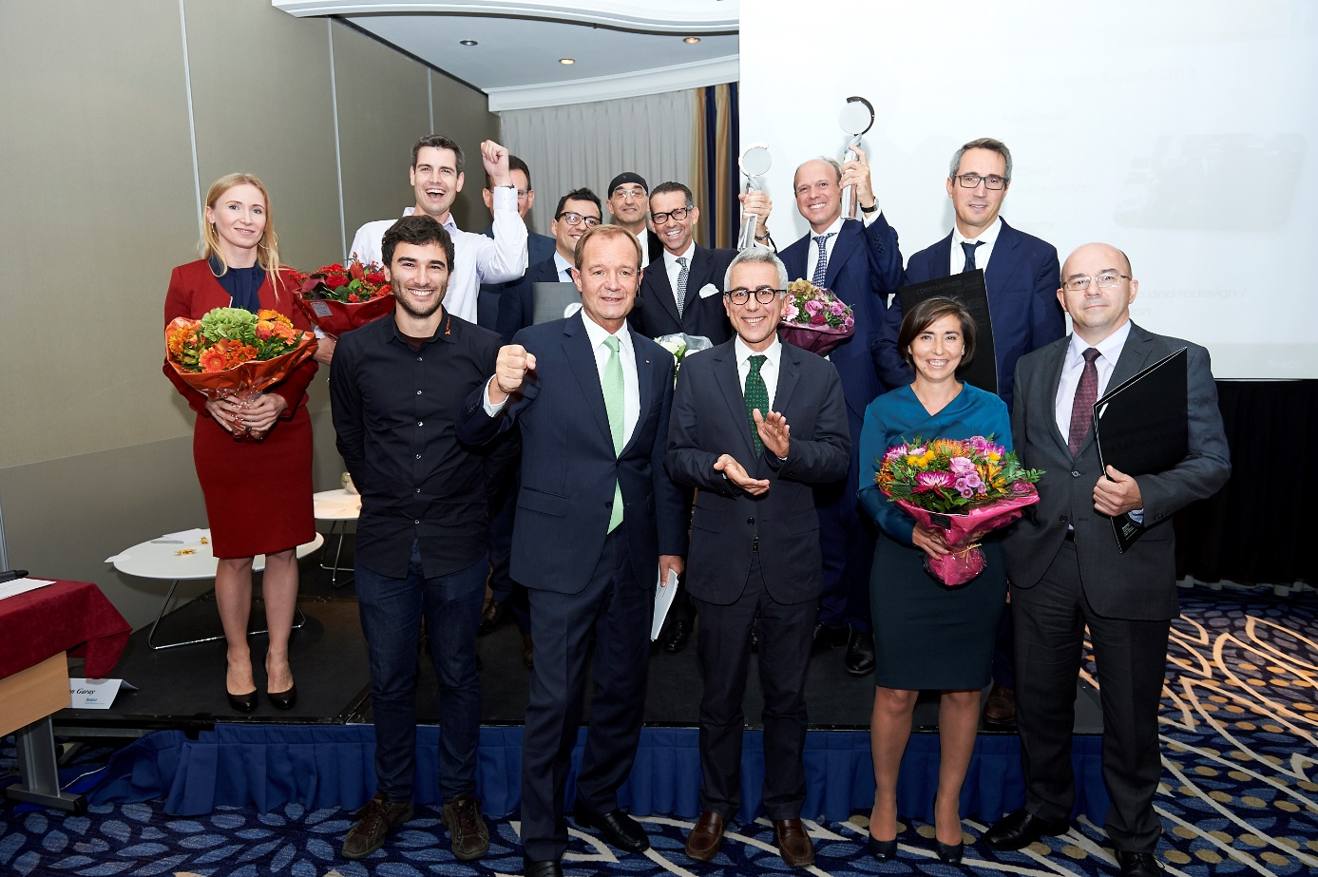
picture (FV UBIT / FEACO) with all Winners:
First row: Bernhard Reisenberger (Red Bull), Alfred Harl (Chair Constantinus Europe), Ezio Lattanzio (Präsident FEACO), silver Medalist Spain
Second Row: Dr. Karin Kappel (RISE), Alexander Mitter (NIMBUSEC), Winners Constantinus European
Third Row: Silver Medalist Austrian SLIM and Prof. Dr. Thomas Grechnig (RISE)

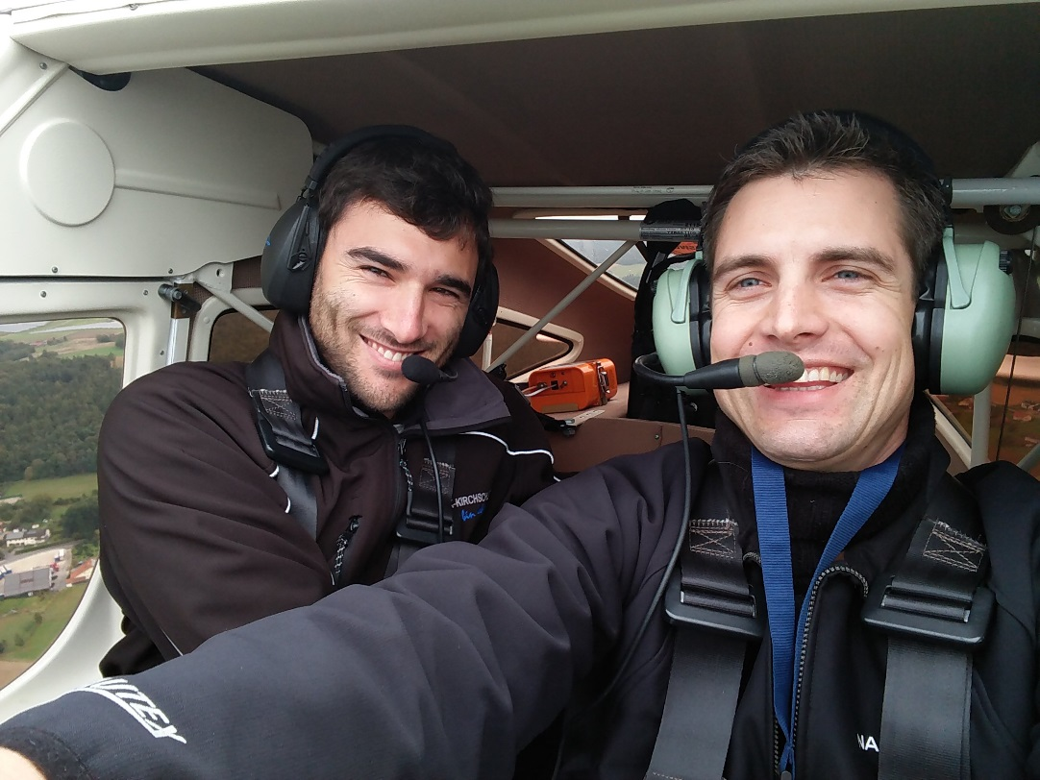
Picture (FV UBIT / FEACO): Alexander Mitter (NIMBUSEC) is flying with his customer Bernhard Reisenberger /RedBull) in his own plane tot he Constantinus European Award.

About FEACO
FEACO, the European Federation of Management Consultancies Associations, is a non-profit organisation which was established in 1960. The Federation counts 12 national member associations. General purpose of FEACO is to assist promotion and development of the profession of Management Consultancy in Europe by providing support to its national association members as one voice that is stronger than the sum of its individual voices. In order to promote European management consulting companies the „Constantinus European Award“ launched in 2012 is still implemented by the Austrian national institute of management consultancy (UBIT).

Press contact
Carina Fröhlich
incite GmbH
Wiedner Hauptstraße 57, 1040 Wien
phone: 0043 5 90 900-3791
fax: 0043 5 90 900-3794
mail: carina.froehlich@incite.at

