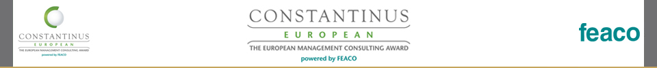

**The Constantinus European Award 2015 took place in Greece.**

*The third Constantinus European Award was handed out on the 15th of October in Athens, Greece.*

The dynamic branch of management consulting is an important sparring partner for businesses and entrepreneurs - especially, when precise expertise and efficient implementation of measures are in demand. "Naturally, the quality of the consulting sector relies heavily on the innovative strengths of the consultants themselves. This is why FEACO has initiated the Constantinus European Award in order to give a prominent stage to all the excellent accomplishments of the branch", states Ezio Lattanzio, chairperson of FEACO.

The primary objective of establishing this award is the promotion of individual outstanding consulting projects not only nationally, but also in Europe. The Constantinus European Award should also serve as a platform for international cooperation in the field. For the nominees, this award will figure an important tool for strengthening the client-consultant-relationship through the celebration of successful joint endeavours in addition to raising the international recognition of their projects.

"The European Constantinus Award honours the beacons of the management consultancy & IT branch on the Europan level and promotes cross-border competition through international comparison", outlines Alfred Harl, Chair Constantinus European, the uniqueness of this award for the European management consultancy and IT branch.

**Gold medal for Greece, silver for Austria and Greece;**

From all the projects submitted an international expert jury chose the nominees and, in turn, the National Champions as well as the winners from these entries. This year’s National Champions are the Austrian Advicum Consulting GmbH, the Spanish everis spain sl and the Greek EUROCONSULTANTS S.A.

This year’s Gold Medal went to the Greek Champion EUROCONSULTANTS S.A. for upgrading and rationalizing the Country’s Fisheries Commercial Chain in the Sultanate of Oman.

Key elements of the Project were the effective handling and commercialization of fisheries from production, to wholesaling, to retailing and to final consumption. The support of domestic consumption and exports as well as strengthening the competitiveness of the Country’s fisheries industry were part of the strategy. In Addition EUROCONSULTANTS S.A. recommended a new legal entity (the Oman Fisheries Services Company -OFSC), designed its structure, operations and capacity to effectively administer and supervise the operations of the proposed new commercial system.

The first of two Silver Medals went to Austrian Champion Advicum Consulting GmbH for the successful restructuring of the globally operating, family-owned company Mayer & Cie. GmbH & Co. KG (MTC) as interim CEO and CRO. After a „Planinsolvenz“ or self-administrated insolvency in 2009 Advicum Consulting GmbH took over to turn around the business. Departments were merged, the vacant spaces leased. Moreover, processes were streamlined and in some divisions productivity was increased by 100%. Also the scrap rate was reduced significantly. Today, MCT is again the clear global market leader! The second Silver medal went to Price Water House Coopers & TEC Business Solutions S.A. from Greece. The company developed a proposal for a new organizational structure of the Hellenic post S.A. (ELTA).

The Key elements of the strategy were developing direct interventions, in order to halting the downward path in revenues (crash program), internal reorganization and developing new products.

**GOLD:**

Participant: EUROCONSULTANTS S.A.

Client: Ministry of Agriculture and Fisheries Wealth (MOAFW) of the Sultanate of Oman

Project: Strategy for the Establishment of a Fish Marketing – Trading Company/ Organization in the Sultanate of Oman. Managing the County’s Fisheries Wealth.

**SILBER:**

Participant: Advicum Consulting GmbH

Client: Mayer & Cie. GmbH & Co. KG

Project: Successful restructuring of a globally operating, family-owned company as interim CEO and CRO.

**SILBER:**

Participant: Price Water House Coopers & TEC Business Solutions S.A.

Client: Hellenic post S.A. (ELTA)

Project: Proposal for a new organizational structure; Strategic & Operational Planning of Hellenic Post S.A. 2013-2017 – Crash Program 2013-2014

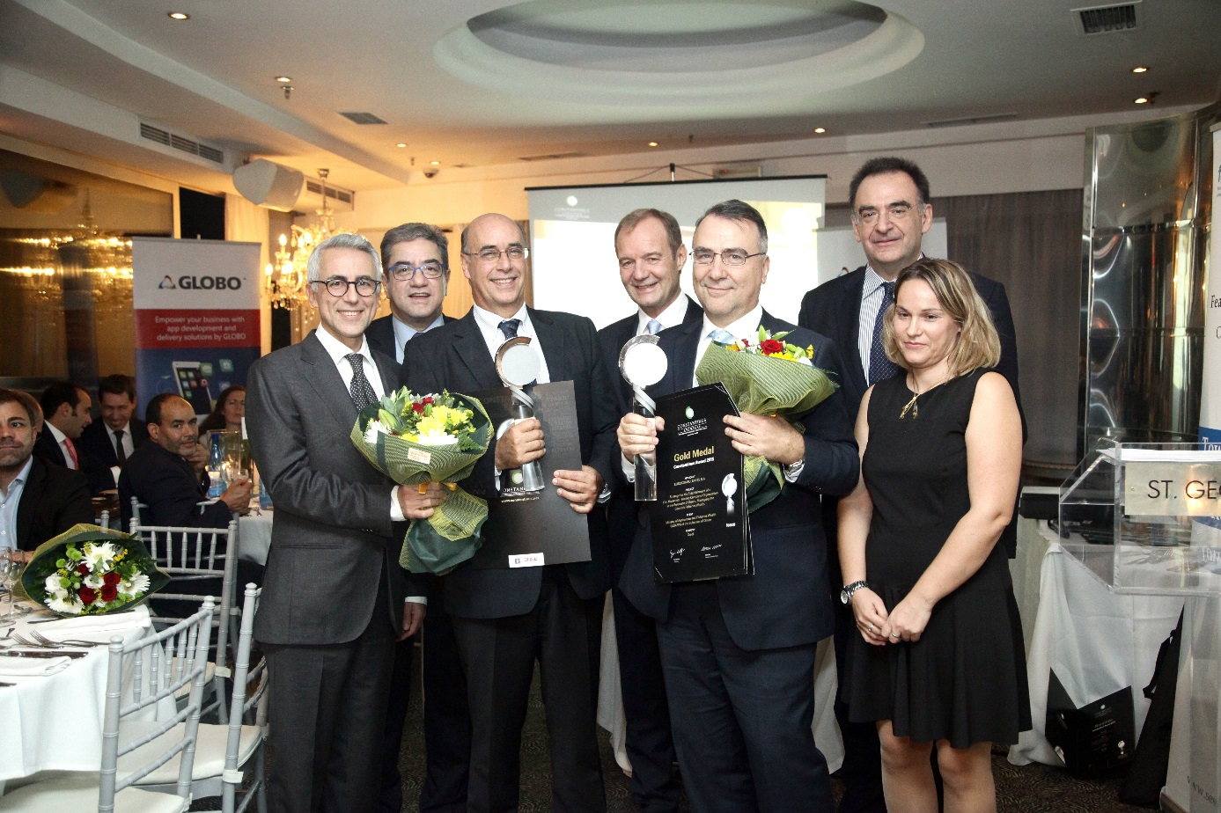

Picture (FV UBIT / FEACO from left: FEACO President Ezio Lattanzio, Mr. Bonanos (Globo), Michael Fronistas (LOCUS), Alfred Harl (Chair Constantinus), Dr. Paris Kokorotsikos (EUROCONSULTANTS A.S.), SESMA Präsident Vasileios Regouzas, Co-Presenter Maria Tsioumani.